**Food Waste Management System**

**Design Document**

**Version 1.0**



**Group Id:** S240265DF4

**Supervisor Name:** Muhammad Hassaan (m.hassaan@vu.edu.pk)

**Revision History**

|  |  |  |  |
| --- | --- | --- | --- |
| **Date (dd/mm/yyyy)** | **Version** | **Description** | **Author** |
| 13/05/2024 | 1.0 | Food Waste Reduction System is used to overcome the serious problem of food wastage by suggesting user recipes based on the fact that if their expiration date is approaching, offering expiration reminders, and providing tips for effective storage of food items to increase freshness duration. User will be able to manage profiles, food inventory, search & filter results, leave their worthy feedback | BC220403459 |
|  |  |  |  |
|  |  |  |  |
|  |  |  |  |

**Table of Contents**

1. Introduction of document
2. Scope (of the project)
3. Functional Requirements Non-Functional requirements
4. Use Case Diagram
5. Work Plan
6. Entity Relationship Diagram (ERD)
7. Database Design
8. Interface Design

1. **Introduction of Document**

This document describes the specifications of the project from various perspectives. My project aims to reduce the food wastage to maximum achievable level by suggesting recipes including leftover ingredients that are approaching their respective expiry date to concerned ones and also guiding them through tips to prolong the freshness of food.

1. **Scope (of the project)**

Food waste management system is a complete system to minimize the food wastage to maximum possible level.

In this system, users can create & manage their profiles and food inventory. Inventory could be entered by two means i.e., manual entry or QR code scanning. The system will suggest the food recipe to the user based on various factors such as availability of ingredients, user’s preference, cooking time, user’s cuisine & meal type. Also, the system can suggest those recipes to those users whose ingredient’s expiration date is approaching.

System provides the user with notification of ingredients who are expected to expire soon. The frequency and timing of notification could be adjusted by the user. Users can also search from inventory and filter the searched results based on his personal preferences and conditions. In the end, users can provide the system with their precious feedback in the form of comments.

1. **Functional Requirements Non-Functional requirements**

**Functional Requirements**

* **User Registration and Profile Management:**
* Users should be able to create accounts and manage their profiles within the system.
* Profile management features should include options to update personal information, dietary preferences, and allergy information.
* **Food Inventory Management:**
* Users should be able to input and manage their food inventory within the system.
* The system should support manual input of food items OR barcode scanning for convenience.
* Each food item entry should include details such as name, quantity, expiration date, and storage location.
* **Recipe Suggestions for Leftover Ingredients:**
* The system should analyze the user's food inventory and suggest recipes based on available ingredients.
* Recipe suggestions should consider the user's dietary preferences, allergies, and cooking skill level.
* Users should be able to filter recipe suggestions by cuisine, meal type, and cooking time.
* **Expiration Date Reminders:**
* The system should provide reminders for approaching expiration dates of food items in the user's inventory.
* Users should be able to customize notification settings for expiration date reminders, including frequency and timing.
* **Food Storage Tips and Guidelines:**
* The app should offer tips and guidelines for storing various types of food to prolong freshness and prevent spoilage.
* **Search and Filter Functionality:**
* Users should be able to search for specific recipes, ingredients, or storage tips within the system.
* The system should support filtering of search results based on various criteria such as ingredient availability, dietary restrictions, and cooking difficulty.
* **User Feedback and Rating System:**
* The system should allow users to provide feedback on recipe suggestions, storage tips, and overall user experience.
* Users should be able to rate recipes they have tried and share comments or suggestions for improvement.

**Non-Functional Requirements**

* **Performance:**
* The system should respond to user actions within a reasonable time frame, even under peak loads.
* For efficient inventory management, the barcode scanning feature should have as little latency as possible.
* For a flawless user experience, response times for search queries and recipe recommendations should be optimized.
* **Scalability**:
* The system should be able to handle an increasing number of users and data without compromising performance.
* Front-end and back-end of the app must be kept upgrading to advance technologies.
* **Compatibility**:
* The system should be compatible with a wide range of devices and web browsers to ensure accessibility for users.
* **Usability**:
* The user interface should be easy to use for every level of user.
* The user interface should be easy-to-use specially for new users.
* **Reliability**:
* The system should be highly available, with minimal downtime of servers for maintenance.
* Regular backups of user data should be taken to prevent data loss in case of any system failure.

1. **Use Case Diagram**

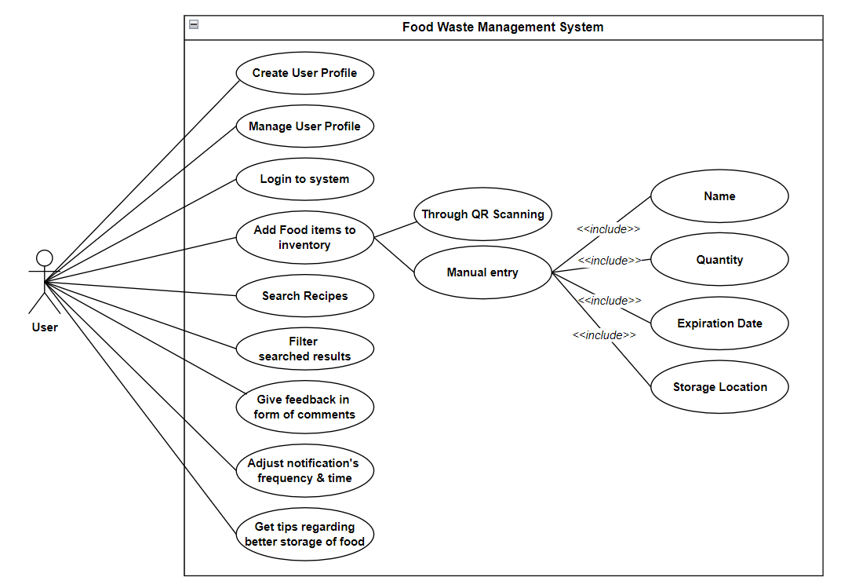

1. **Work Plan**

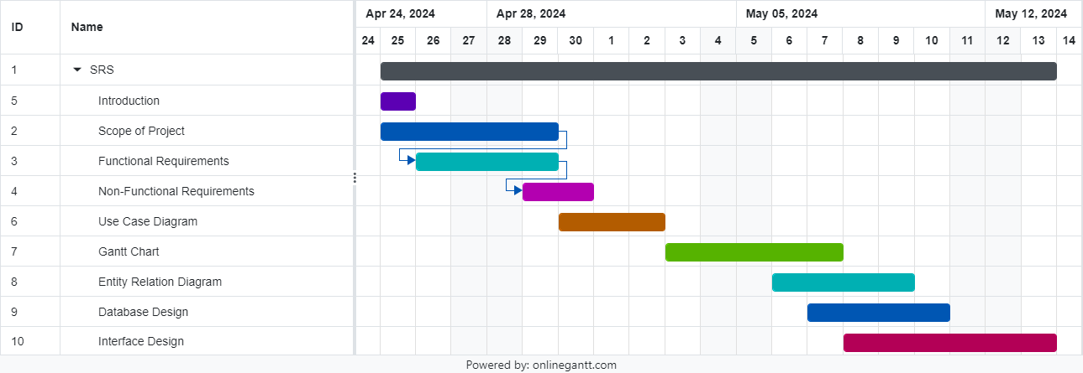

1. **Entity Relationship Diagram (ERD)**

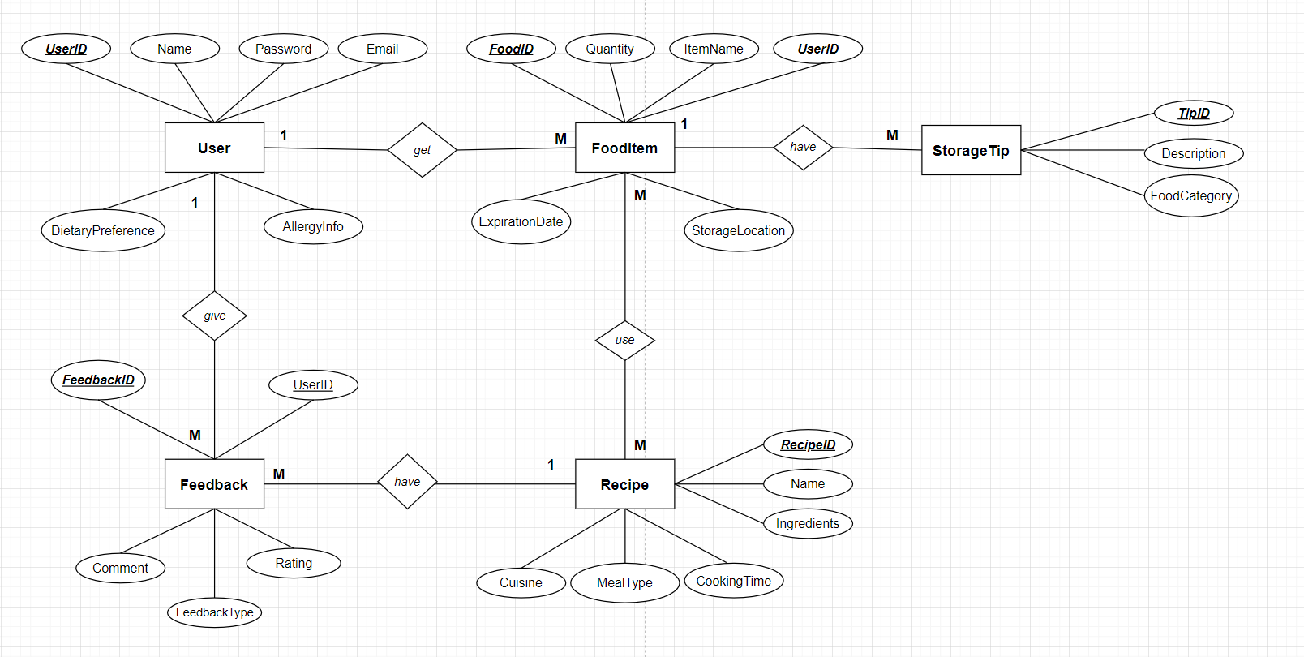

1. **Database Design**

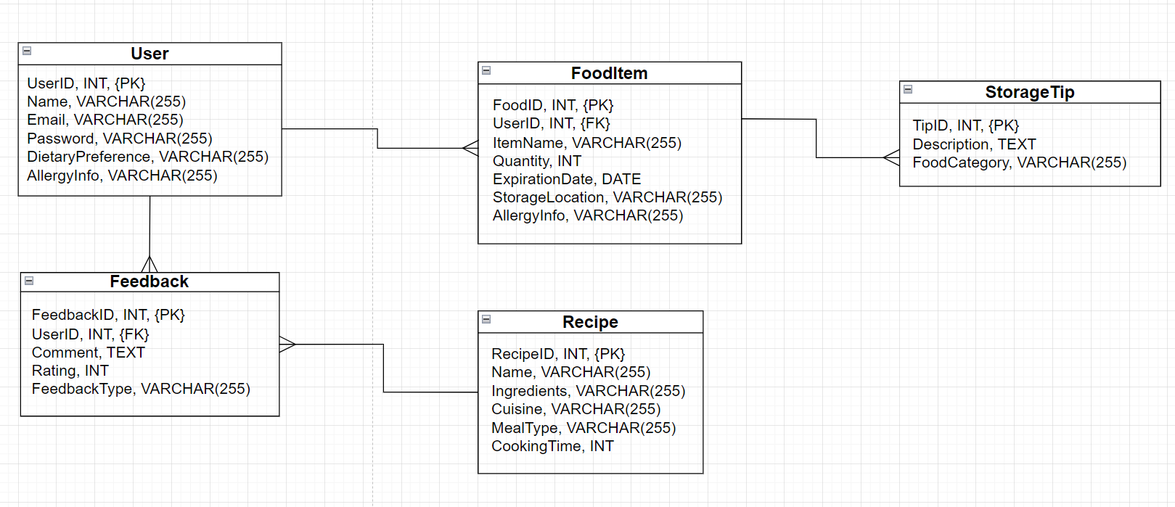

1. **Interface Design**

Main Interface (Login Page):

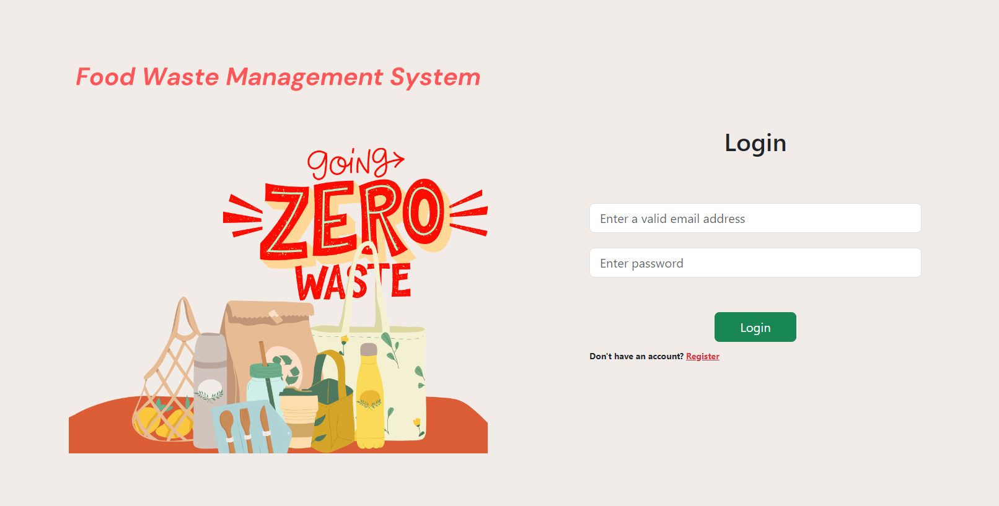

Sign up Page:

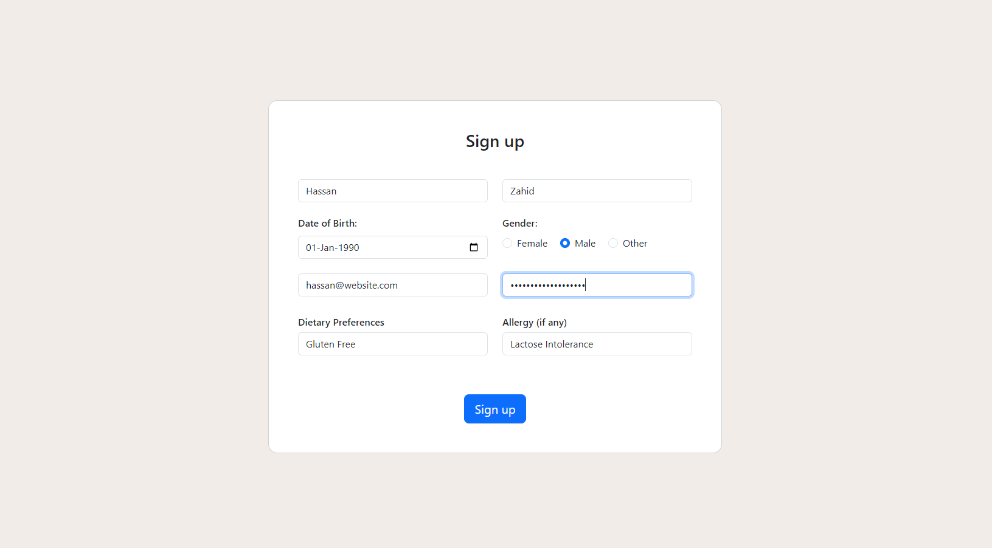

Add Inventory Page:

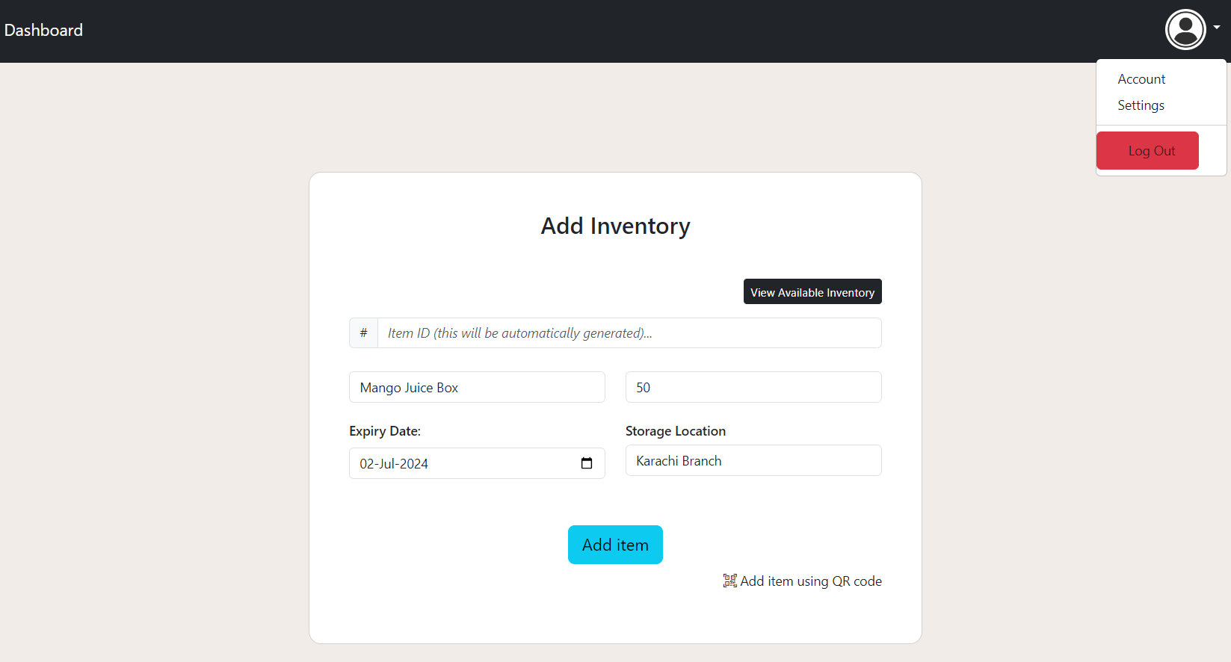

View Inventory Page:

